### 

### 

### **Product Dissection for Google Meet**

**Company Overview:**

Google Meet, developed by Google, is a video conferencing service that has become an essential tool for remote communication and collaboration. Launched in 2017 as part of the Google Workspace suite, Google Meet provides secure and high-quality video meetings for businesses, educational institutions, and personal use. Its integration with other Google services, such as Gmail and Google Calendar, has made it a popular choice for seamless and efficient virtual meetings.

### **Product Dissection and Real-World Problems Solved by Google Meet**

Google Meet addresses several real-world challenges through its comprehensive video conferencing solutions. By focusing on accessibility, security, and user-friendliness, Google Meet has become a critical tool in the digital age, enabling remote work, online education, and virtual social interactions.

#### **Problem 1: Remote Communication and Collaboration**

**Real-World Challenge:** The shift towards remote work and virtual learning has created a need for reliable and efficient communication tools. Traditional in-person meetings and classrooms require digital alternatives that can offer the same level of engagement and interaction.

**Google Meet's Solution:** Google Meet provides a robust platform for video conferencing, supporting high-definition video and audio for up to 250 participants. Features such as screen sharing, real-time captions, and breakout rooms enhance collaboration and engagement, making it easier for teams to work together and for educators to conduct classes online.

#### **Problem 2: Security and Privacy Concerns**

**Real-World Challenge:** With the rise of cyber threats and privacy concerns, ensuring the security of virtual meetings has become a top priority for organisations and individuals.

**Google Meet's Solution:** Google Meet offers enterprise-grade security, including encrypted video meetings, secure access controls, and anti-hijacking measures. Users can host meetings with confidence, knowing that their data and conversations are protected by Google's advanced security infrastructure.

#### **Problem 3: Accessibility and Inclusivity**

**Real-World Challenge:** Ensuring that all users, regardless of their technical proficiency or physical abilities, can participate in virtual meetings is essential for inclusivity.

**Google Meet's Solution:** Google Meet includes features such as live captions, adjustable layouts, and compatibility with assistive technologies. These features make the platform accessible to users with hearing impairments, different learning needs, and varying levels of tech-savviness, promoting inclusivity and equal participation.

#### **Problem 4: Seamless Integration with Tools and Workflows**

***Real-World Challenge*:** Professionals and students often use multiple tools for their daily tasks, and integrating a new platform without disrupting existing workflows can be challenging.

**Google Meet's Solution:** Google Meet integrates seamlessly with other Google services like Gmail, Google Calendar, and Google Drive. This integration allows users to schedule and join meetings directly from their email or calendar, share documents during meetings, and store recordings in Google Drive, streamlining workflows and enhancing productivity.

### **Top Features of Google Meet:**

* **High-Quality Video and Audio:** Supports up to 720p HD video and high-quality audio, ensuring clear communication.
* **Screen Sharing:** Allows participants to share their screens or specific application windows for presentations and collaboration.
* **Real-Time Captions:** Automatically generated captions help participants follow the conversation, particularly useful for those with hearing impairments.
* **Breakout Rooms:** Facilitates small group discussions within larger meetings, enhancing engagement and collaboration.
* **Meeting Recording:** Users can record meetings and save them to Google Drive for later reference or sharing.
* **Security Features:** End-to-end encryption, secure access controls, and robust privacy protections ensure safe meetings.
* **Integration with Google Services:** Seamlessly integrates with Gmail, Google Calendar, and other Google Workspace tools.
* **Mobile Compatibility:** Fully functional on mobile devices, allowing users to join meetings on the go.

### **Schema Description**

The schema for Google Meet involves multiple entities that represent different aspects of the platform. These entities include Users, Meetings, Participants, Messages, and more. Each entity has specific attributes that describe its properties and relationships with other entities.

#### **User Entity:**

Users represent the individuals using Google Meet.

* **UserID (Primary Key):** A unique identifier for each user.
* **Username:** The chosen username for the user's account.
* **Email:** The user's email address for account-related communication.
* **Full_Name:** The user's full name as displayed on their profile.
* **Registration_Date:** The date when the user joined Google Meet.

#### **Meeting Entity:**

Meetings capture the details of scheduled video conferences.

* **MeetingID (Primary Key):** A unique identifier for each meeting.
* **HostID (Foreign Key referencing User Entity):** The user who created/hosted the meeting.
* **Title:** The title or topic of the meeting.
* **Start_Time:** The scheduled start time of the meeting.
* **End_Time:** The scheduled end time of the meeting.
* **Creation_Date:** The date when the meeting was created.

#### **Participant Entity:**

Participants are the users who join the meetings.

* **ParticipantID (Primary Key):** A unique identifier for each participant.
* **MeetingID (Foreign Key referencing Meeting Entity):** The meeting being joined.
* **UserID (Foreign Key referencing User Entity):** The user who joined the meeting.
* **Join_Time:** The time when the participant joined the meeting.
* **Leave_Time:** The time when the participant left the meeting.

#### **Message Entity:**

Messages enable communication within the meetings.

* **MessageID (Primary Key):** A unique identifier for each message.
* **MeetingID (Foreign Key referencing Meeting Entity):** The meeting in which the message was sent.
* **UserID (Foreign Key referencing User Entity):** The user who sent the message.
* **Text:** The content of the message.
* **Timestamp:** The time when the message was sent.

#### **Recording Entity:**

Recordings capture the details of meeting recordings.

* **RecordingID (Primary Key):** A unique identifier for each recording.
* **MeetingID (Foreign Key referencing Meeting Entity):** The meeting that was recorded.
* **UserID (Foreign Key referencing User Entity):** The user who initiated the recording.
* **Recording_URL:** The URL where the recording is stored.
* **Start_Time:** The time when the recording started.
* **End_Time:** The time when the recording ended.

### ***Relationships:***

* **Users host Meetings:** Each user can host multiple meetings.
* **Users join Meetings:** Users can join multiple meetings, and each meeting can have multiple participants.
* **Users send Messages in Meetings:** Users can send multiple messages in a meeting, and each meeting can have multiple messages.
* **Meetings have Recordings:** Each meeting can have multiple recordings.

### 

### 

### 

### 

### 

### ***ER Diagram***

Let's construct an ER diagram that vividly portrays the relationships and attributes of the entities within the Google Meet schema. This ER diagram will serve as a visual representation, shedding light on the pivotal components of Google Meet's data model. By employing this diagram, you'll gain a clearer grasp of the intricate interactions and connections that define the platform's dynamics.

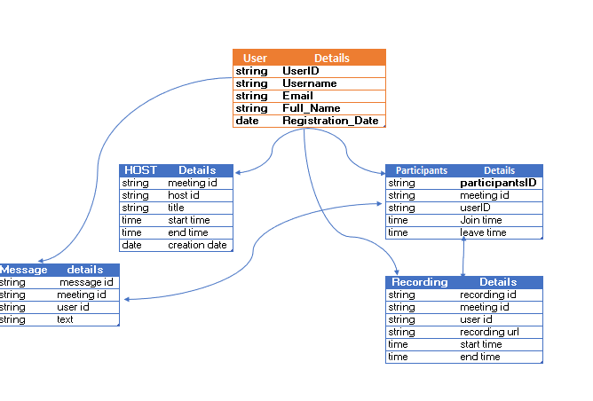

*Conclusion*

In this case study, we delved into the design of Google Meet's schema and Entity-Relationship diagram. Google Meet has revolutionised remote communication and collaboration by addressing critical challenges related to accessibility, security, and seamless integration. The platform's intricate data model, consisting of entities like users, meetings, participants, messages, and recordings, forms the foundation for its seamless functionality. By understanding this schema, we gain insight into how Google Meet effectively manages the complexities of virtual meetings, contributing to its widespread adoption and continued growth in the realm of digital communication.

### 

### 

### 

### 